LAB EXERCISE

DrawHouse

**Background**:

You will be provided with a file named apcslib.jar, which contains the code needed to implement the graphics tools to draw objects. The specifications of the drawing tools are provided in *Handout H.A.1.1 – DrawingTool*. Simply place the apcslib.jar file in the appropriate folder location so the Java compiler can find it. Then add this line of code

**import** apcslib.*;

at the top of your program and the drawing tools are available for use.

**Assignment:**

Write a program that creates a drawing area of appropriate size (try 500 x 500) and draws a house similar to the one shown below and with these specifications:

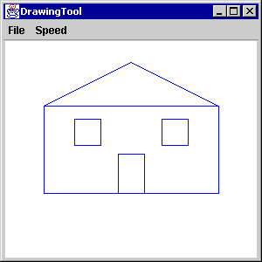

1. The house should fill up most of the drawing area, i.e. draw it big.

2. The house should be centered horizontally on the screen.

3. The house must have a sloped roof. It can be of any slope or configuration. But you cannot have a flat roof on the house.

4. Adding a door (centered) and windows is optional.

**Instructions:**

1. Include your name as a documentation statement and also a brief description of the program.

2. You will need to turn in (either on paper or electronically) a copy of your code and a picture of the house that resulted.